**Client Overview :**

Project is for a client from tech entertainment industry and the company is great at facilitating bookings for various festivals, events, private function, weddings and university gatherings on a global scale.

In simple words : Presenters engage with company(client) to secure artist for their events and the company helps them through various network of agents on conducting their events successfully.

**Business Operations : (How does it work)**

* The company has various networks of agents which helps in assisting presenters(customers) and securing talented artist for their events. This involves proper planning of some process such as tickets booking, working with presenters to identify suitable talented artist, coordinating additional requirements etc.
* Agents at the company operate on a commission-based structure and earns compensation for each completed event.
* With strategic presence in multiple states across US. **The company focuses on local markets to better serve its diverse range of clients**.
* The company has internal CRM tool that manages entire process from initial connection to final payments.

**Objectives of data analyst and machine learning**

Sales director of the company is tasked with developing key sales statistical and analytical insights to grow the company to make informed business decisions. These analyses serves as evaluating agent performance, revenue, expenses and probability. These insights will help them to steer the agency towards sustained growth and success in dynamic entertainment landscape.

**Data Flow Exploration**

1. Blue card creation – presenter’s details, event information and venue details are entered.

Primary entities : BlueCard, Artist, Presenter, Venue

1. Artist Enrollment – when artist enrolls in program data regarding the artist program and enrollment specifics are captured

Primary entities : ArtistProgramEnroll, ArtistProgram, Artist.

1. Contract Creation – when contract is created info of the agreement b/w artist, presenter and venue is captured.

Primary entities : Contract, Artist, Presenter, Venue.

**Data Processing**

1. Promo and marketing - info from BlueCardPromo, BlueCardPromoArtist is processed to generate promotional materials.
2. Financial transactions - financial data flows through various entities including ContractPayment, AgentPayment, PayrollBatch.
3. Contract Management - Data related to contracts moves through entities such as Contract, ContractArtist, ContractTransaction and ContractEventDate.

Most data stored in tables like – BlueCard, Contract, Artist, Presenter and Venue.

Past data stored in tables like – Archived Contracts, old Event Details, Past Artist Programs

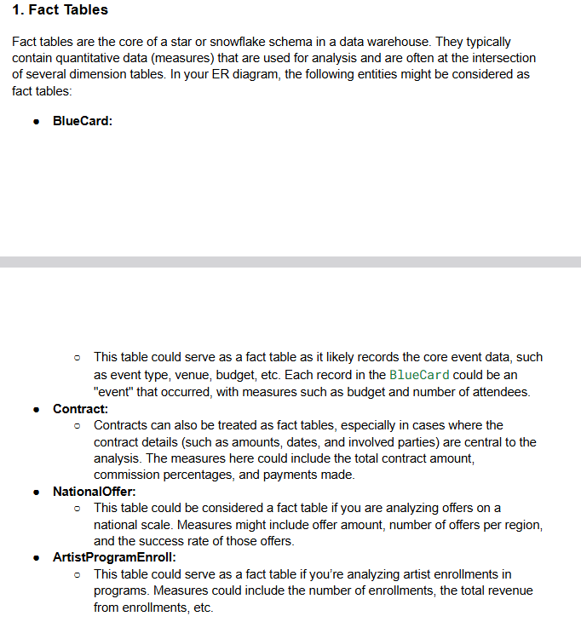

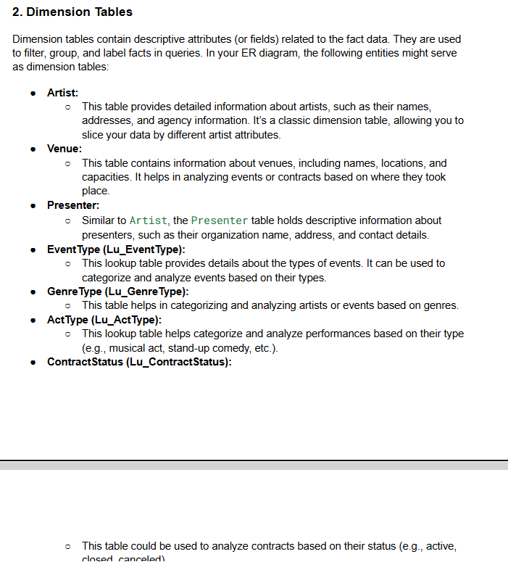

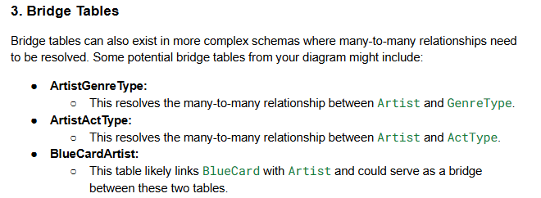

**Relationship between tables**

1. A >|----------||- B: - One to One relationship between A and B

Means : A optionally linked to one instance of B and B must be linked to one instance of A

Eg: Every passport belongs to exactly one user but every user may or may not have passport.

1. A >o---------||- B: - Many to One relationship (N : 1)

Means : Multiple instances of A can optionally be linked to exactly one instance of B and B must be linked to one or more instances of A

Eg: Each Employee belongs to one department but a department can have many employees.

1. A +o---------||- B: - Also One to One relationship between A and B but optional participation from both sides.
2. A >o--------o+ B: - Many to Many relationship

Means : Multiple instances of A can be linked to multiple instances of B and both sides can have optional participation.

For the next stage to perform data cleaning, feature engineering and EDA

* All the 189 tables have same columns in common with each other

From the ERD diagram I have chosen ‘National Offer table’

In the database it is mentioned as ‘OFFER’

Reason :

* Important as we can know about various events, orders, tickets, channels or promotions.
* Often used in **reporting, recommendation engines, and sales optimization.**
* Client insights → via BuyerName, BuyerEmail, SignerEmail
* Event quality → via IsTicketedEvent, VenueName, VenueCapacity
* How many offers are **in progress vs closed** (IsInProgress, OfferStatusId)
* **Conversion rates** of offers to confirmed bookings

Highlights of the Project

* First was Data cleaning and checking if null values were present and there were null values
* Filling out the null values either using median or mode method.
* Checking and visualizing the outliers
* No duplicates present in the data.
* Dropping out columns like ['ProductionContactName',  'ProductionContactPhone',

                      'ProductionContactEmail',

                      'ProductionContactWebsite',

                      'MailingAddress2',

                      'BuyerFax',

                      'SignerTitle',

                      'SignerFax',

                      'VenuePhysicalAddress2',

                      'VenueContactTitle',

                      'VenueContactEmail',

                      'VenueContactFax',

                      'ProductionCompany',

                      'UrlKey]

* Performing feature engineering
* Correlation analysis
* Then Dropped columns[OfferId',BuyerId,BuyerName ] to proceed into visualization which doesn’t give any insights.

**VISUALIZATION ANALYSIS FINDINGS**

1. Count of offers by presenters – East Coast Entertainment and Roanake Rapid theatres stands the most
2. VenueCapacity by Venue Setting type – Here 1.0, 2.0 and 3.0 (could be referred to as hybrid, outdoor or indoor venue)
3. How many offers for each signer are in progress
4. Count of Offers by Venue – Roanake Rapid theatre stands the most
5. Count of ticket vs non ticket events (Which events are likely to be having tickets)
6. In Progress vs completed offers
7. Venue Capacity distribution
8. Ticket events are either public or private
9. Number Tickets and Non ticket event by presenters ( which means which events do we require to have tickets to attend the event)
10. Top 15 cities by Average Venue Capacity
11. Most frequent combinations of PresenterName, VenueName, SignerName - The ROANOKE RAPIDS THEATRE and Elizabeth Branham teamed up six times at the same venue. That suggests a trusted partnership or recurring event series.